Dear SEIAPI Members             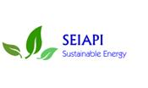

Welcome to the October 2014 Newsletter. In this issue:

* 1. IRENA PPA SEIAPI Design and Install Grid Connect Training
  2. Certification and Accreditation
  3. Annual General Meeting
  4. World Bank Funding proposal
  5. PACTVET
  6. Website
  7. Membership update

**IRENA/PPA/SEIAPI Design and Install Grid Connect Training**

In recent months four more practical training courses have been conducted. Two were held in Kiribati in June and in September one was held in Marshall Islands and one in Tonga. A total of 28 people attended the 4 courses.

The practical training courses were funded by IRENA though a project being managed jointly by PPA and SEIAPI.

This project has now been completed with a total of 56 people registering to do the online course and 48 attending one of the 6 practical courses that have been conducted. Three people who were unable to attend in-country courses have attended practical training courses in Sydney.

This project has provided the opportunity fro people to undertake training which upon successful completion of all assessments makes them eligible for provisional certification in the design and installation of grid connect PV systems. Buy June 2015 it is anticipated that at least 50 people will be certified as a result of this project.

The SEIAPI executive would like to thank IRENA for their support.

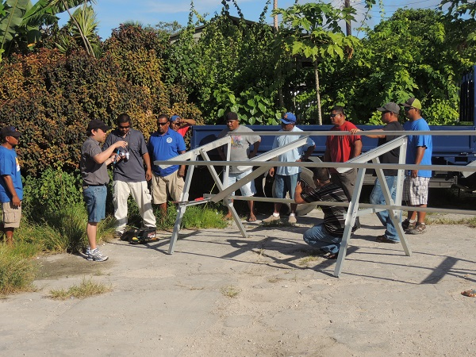

**Participants erecting array frame in Marshall Islands.**

**Certification and Accreditation Program**

SEIAPI and PPA are pleased to announce that as a result of the IRENA funded project there are now 8 technicians in Fiji provisionally certified and two companies Clay Energy and CBS Power are provisionally accredited.

Last year 2 week face-to-face training courses were conducted in Palau and Cook Islands. These courses were conducted in accordance with the competency standards developed by technical committees of the Renewable Energy & Energy Efficiency Training Competency Standards Advisory Committee.

SEIAPI is currently writing to all those who successfully completed those courses inviting them to apply for provisional certification.

**AGM**

After a number of attempts that failed due to Internet issues the AGM was finally conducted on 19th August 2014. The minutes of the meeting had previously been distributed to members.

The following people were elected or re-lected to the executive committee:

President Peter Konings (Guan/Pohnpei)

Vice-President North Pacific:                                     Gilbert J Charfaurus (Guam)

Vice President South Pacific:                                     David Iro Fulaga (Solomon Islands)

Treasurer:                                                                   Bruce Clay (Fiji)

Secretary:                                                                   Geoff Stapleton (Australia)

Ordinary Members:                                  Nick Ritsinias (Vanuatu);

Nikolsai Fonua (Tonga)

Gavin Pereira (Solomon Islands)

Previous committee members Faustino Yangmog (Yap-FSM) and Lano Fonua (Tonga) had indicated that they did not want to re-stand for their positions.

The president wishes to thank Mr Faustino Yangmong and Mr Lano Fonua for their involvement in the committee.

**World Bank Funding Proposal**

Since the last newsletter SEIAPI and PPA have had  a meeting with  NZ MFAT and representatives from the World bank Sydney office. SEIAPI and PPA are now working with the World Bank to tailor the proposal in line with the funding available under the World Bank’s Scaling up Renewable Energy in low income countries Program (SREP).

This proposal will be submitted for the next review meeting which is in March 2015 and if successful SEIAPI and PPA will be able to commence the project about June 2015.  This will allow SEIAPI the opportunity to start to implement many of the activities outlined in the business plan developed in 2012.

SEIAPI will be attending a mission to Fiji in November 2015 to continue the proposal development.

**European Union Pacific Technical and Vocational Education and Training on Sustainable Energy and Climate Change Adaptation (PACTVET)**

The PACTVET is an approximately 6 Million-Euro project that will be administered by SPC with support from the USP. The object of the project is to strengthen the technical and vocational training centres in the Pacific ability to conduct training courses on sustainable energy and climate change adaption.

This project will be benefit SEIAPI members because it will provide more opportunities for their staff to attend training courses and it will also support the growth of the SEIAPI/PPA certification and accreditation program.

The project is due to start in 2015 however SEIAPI secretariat is in communications with EU, SPC and USP in Fiji and is travelling to Suva in coming weeks to have a meeting with respect to the project.

**WEBSITE**

Unfortunately the website is still unavailable due to it being compromised by hackers last year. Bruce Clay and Geoff Stapleton are working with a new website company in Australia and it is hoped that it will be operating again very soon.

Due to the issue the website will be changing to www.seiapi.com

The secretariat can now receive e-mails at [info@seiapi.com](mailto:info@seiapi.com) and the president at president@seiapi.com.

**Membership Update**

The secretariat has not been actively seeking new members while it has been concentrating on securing funding to facilitate a full time person. In the coming weeks the association is going to start a new membership drive particularly for those companies not based on the region but operating and/or supplying product to the region.

**Current membership is 65 comprising:**

Industry members 32

Associate Members 16

Honorary Members 17